AI Chatbot Using Cloud Storage
PROJECT REPORT
Submitted in partial fulfilment of the requirements Third Year for the award of the degree of Computer Engineering

Done by,

Mayank Anil Sanjay (Roll no.46)

Kalpesh Vilas Jadhav (Roll no.17)

Vaibhav Dinesh Marathe (Roll no.28)

Guide:
Prof. M. Mohite


DEPARTMENT OF COMPUTER ENGINEERING
Konkan Gyaanpeeth College Engineering, Karjat
(Affiliated to Mumbai University, Mumbai)
(2024-2025)

CERTIFICATE

This is to certify the cloud computing project entitled “AI Chatbot using Cloud Storage” is a Bonafide work of Mayank Anil Sanjay-46, Kalpesh Vilas Jadhav-17, Vaibhav Dinesh Marathe-28, submitted to be University of Mumbai in partial fulfilment of the requirement for the award of the degree of “T.E.” in “Computer Engineering”.

Prof. M. Mohite
Guide

Prof. S. M. Patil Dr. V. J. Pillewan
Head of Department Principal

KONKAN GYANPEETH COLLEGE OF ENGINEERING, KARJAT.
(Affiliated to University of Mumbai, Approved by A.I.C.T.E., New Delhi.)

Konkan Gyaanpeeth Shaikshanik Sankul, Vengaon Road, Dahivali, Karjat, Dist.-Raigad.410201. (M.S.)

Department of Computer Engineering

Project Report Approval

This project report entitled “AI Chatbot using Cloud Storage ” by “Mayank Anil Sanjay (46), Kalpesh Vilas Jadhav (17), Vaibhav Dinesh Marathe (28)” is approved for the Third Year of Department of Computer Engineering.

Examiners

- .........................................

- .........................................

Date. Place.

Declaration

We declare that this written submission represents our ideas in my/our own words and where others' ideas or words have been included, we have adequately cited and referenced the original sources. We also declare that We have adhered to all principles of academic honesty and integrity and have not misrepresented or fabricated or falsified any idea/data/fact/source in our submission. We understand that any violation of the above will be cause for disciplinary action by the Institute and can also evoke penal action from the sources which have thus not been properly cited or from whom proper permission has not been taken when needed.

Mayank Anil Sanjay (46) Kalpesh Vilas Jadhav (17)
Vaibhav Dinesh Marathe (28)

Date:

ACKNOWLEDGEMENT

We are heartily grateful to our project guide Prof. M. Mohite , HOD of Computer department Prof. S.M. Patil, Principal of KGCE, Karjat Dr. V.J. Pillewan for their being a constant source of encouragement at various stages of the completion of this project. We want to thank our parents and lord, because without their blessing, perhaps we could do nothing. We wish to thank all our friends, colleagues and the campus staff (Department of Computer Engineering), who have help us with the critical review of this project including my Friend’s. Their Debugging skills and grateful appreciated.
Special thanks to my Head of the Computer Department Prof. S. M. Patil for his advice and encouragement.
We must thankful to the various Authors who have contributed material for this project.

Mayank Anil Sanjay (46) Kalpesh Vilas Jadhav (17) Vaibhav Dinesh Marathe (28)

AI CHATBOT
KONKAN GYANPEETH COLLEGE OF ENGINEERING

TABLE OF CONTENTS
- INTRODUCTION 1
  - EXISTING SYSTEM 2
  - PROBLEM STATEMENT 3
  - OBJECTIVES 4
  - SCOPE 5
  - PROPOSED SYSTEM 6
- REVIEW OF LITERATURE 8
- SYSTEM SPECIFICATION 10
  - SOFTWARE SPECIFICATION 11
  - HARDWARE SPECIFICATION 11
- SYSTEM DESIGN 12
- FUTURE SCOPES 15
- CODE 17
- RESULT 21

ABSTRACT

This project presents the development of an AI-powered chatbot integrated with Supabase, a backend-as-a-service platform that provides scalable cloud storage and real-time database capabilities. The chatbot leverages natural language processing (NLP) to understand and respond to user queries intelligently, creating an interactive and human-like conversational experience. Supabase serves as the backend to store user data, conversation history, and dynamic content, enabling persistent sessions and personalized interactions. This architecture enhances the chatbot's functionality by enabling real-time data access, secure authentication, and seamless scalability. The integration of AI with Supabase demonstrates a modern approach to building intelligent applications with minimal backend management, making it ideal for educational, customer support, and productivity-enhancing .

Chapter no.1
INTRODUCTION

AI Chatbot

1.1. INTRODUCTION

Artificial Intelligence (AI) has revolutionized the way humans interact with technology, with chatbots emerging as one of the most practical and widely used applications. An AI chatbot is a software application that uses natural language processing (NLP) and machine learning techniques to simulate human conversation. These bots are commonly used in customer service, education, healthcare, and many other domains to provide quick, automated, and intelligent responses.

To enhance the functionality and scalability of AI chatbots, integrating them with cloud-based backend services is becoming increasingly popular. Supabase, an open-source Firebase alternative, provides a powerful set of tools such as real-time databases, authentication, storage, and serverless functions that can be easily integrated with modern web and mobile applications.

This project focuses on building an AI chatbot that utilizes Supabase for storing user data, managing conversations, and handling real-time updates. The combination of AI capabilities with Supabase’s cloud infrastructure ensures a reliable, scalable, and secure solution that can be deployed across various platforms. This setup allows developers to focus on creating intelligent features while relying on Supabase to manage backend operations efficiently.

Existing System

Traditional chatbot systems are often built using rule-based logic or limited natural language processing, and typically rely on local storage or fixed backend servers for storing data. These systems usually face several challenges such as:
1. Limited Scalability: Local storage or on-premises servers can struggle with high traffic or concurrent users, making it hard to scale applications efficiently.
2. Static Data Handling: Most existing systems store data in static files or databases that do not support real-time updates, leading to delays or outdated responses.
3. Complex Backend Management: Developers need to manually handle server configurations, database connections, and data synchronization, which increases development time and maintenance efforts.
4. Lack of Personalization: Without a dynamic storage solution, chatbots in existing systems often fail to retain user context or provide personalized interactions across sessions.
In addition, many existing chatbots do not support seamless integration with cloud platforms, which limits their ability to offer real-time features, cross-platform synchronization, and secure user data management. These limitations create a need for a more robust and modern solution that leverages cloud infrastructure to enhance chatbot functionality.

Problem Statement

Traditional chatbot systems often struggle with scalability, real-time data access, and personalized user experiences due to limited backend infrastructure. Managing server-side operations, user data, and dynamic content becomes complex and inefficient. There is a need for an intelligent chatbot solution that leverages cloud-based services like Supabase to provide scalable storage, real-time communication, and secure user data management, enhancing both performance.

Objectives

- Develop an AI-powered chatbot capable of understanding and responding to user queries using natural language processing (NLP).

- Integrate Supabase as the cloud backend to manage user authentication, real-time database, and storage.

- Enable real-time data handling for smooth and interactive conversations.

- Store and retrieve conversation history to support personalized user experiences.

- Ensure scalability and security using cloud-based infrastructure.

6. Create a user-friendly interface for easy access across web or mobile platforms.

SCOPE

This project focuses on designing and developing an AI chatbot integrated with Supabase as a cloud backend. The chatbot will utilize natural language processing to interact with users in a human-like manner. Supabase will handle key backend functions including user authentication, real-time database management, and secure cloud storage.

The system will support storing user queries, chatbot responses, and conversation history to enable personalized interactions. The chatbot will be accessible via web or mobile platforms and designed to scale as user demand grows. While the current scope includes basic conversational capabilities and real-time data handling, future enhancements may include advanced AI learning, multilingual support, and integration with third-party services.

PROPOSED SYSTEM

The proposed system is an AI-powered chatbot integrated with Supabase for cloud-based backend services. The chatbot will use natural language processing (NLP) to understand and respond to user inputs intelligently. Supabase will manage real-time data operations, user authentication, and secure cloud storage of user data and conversation history.

This system addresses the limitations of traditional chatbots by offering real-time communication, seamless data synchronization, and scalability. It ensures a personalized user experience by storing and retrieving past interactions, while Supabase’s backend-as-a-service platform reduces the need for manual server management. The chatbot will be accessible on web or mobile platforms ,providing a responsive and interactive interactive experience for users.

Chapter no. 2
REVIEW OF LITERATURE

Review of literature

This paper provides a comprehensive survey of the implementation of chatbots in customer service management. It explores various aspects such as the adoption rate of chatbots, challenges faced by organizations during implementation, and the impact of chatbots on customer satisfaction. The study also discusses different strategies for integrating chatbots into existing customer service systems and highlights best practices for successful [2].
This survey paper focuses on natural language processing (NLP) techniques used for building conversational agents or chatbots. It reviews the latest advancements in NLP, including techniques for intent recognition, entity extraction, dialogue management, and sentiment analysis. The paper also discusses challenges in NLP-based chatbot development and identifies opportunities for future research in this area.This literature review examines the application of chatbot technologies in healthcare settings.[3]
It discusses the potential benefits of using chatbots for patient engagement, symptom assessment, medication adherence, and healthcare information dissemination. The paper also addresses privacy and security concerns related to healthcare chatbots and highlights the need for further research to evaluate their effectiveness in improving healthcare outcomes.[4]

Chapter no. 3
SYSTEM SPECIFICATION

SYSTEM SPECIFICATION
User Interaction: NLP for understanding queries and multi-turn conversations. Information Retrieval: Access to a knowledge base.
Context Management: Maintain conversation context. Personalization: Adapt responses based on user history. Integration: Connect with existing systems (e.g., CRM).

      - SOFTWARE REQUIREMENTS

Languages: Programming languages (e.g., Python).
Libraries: Frameworks and libraries (e.g., Streamlit, env).
APIs: APIs for additional functionalities. Chat Interface: Design mockups (if applicable).

HARDWARE SPECIFICATION

Processor Intel Pentium or above.

Hard Disc 128GB.

Display Type PC Display

Keyboard PC/AT Enhanced PS/2Keyboard

Mouse First/Pilot Mouse Serial (c48).

Input Device Mouse, keyboard

Output Device Monitor, Mobile Display

Chapter no.4
SYSTEM DESIGN

  - DATA FLOW DIAGRAMS

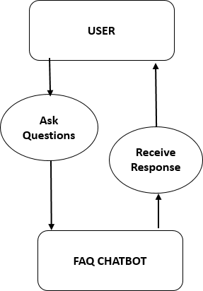

Fig : Basic flowchart

ASK/PROCESS
API
CHAT
WEB
HISTORY PAGE
RESPONSE

USER
Fig. : Flowchart

Chapter no.5
Future Scopes

Future scopes

1. Multilingual Support: Extend the chatbot to handle conversations in multiple languages for broader accessibility.

2. Voice Interaction: Integrate speech recognition and text-to-speech for voice-based communication.

3. AI Learning Capabilities: Implement machine learning to enable the chatbot to learn from user interactions and improve over time.

4. Third-party Integration: Connect with external APIs and services (e.g., calendars, CRM tools) to enhance functionality.

5. Analytics Dashboard: Develop an admin panel to monitor chatbot performance and user engagement.

6. Mobile App Deployment: Expand the system to dedicated Android and iOS apps for better user reach.

GANTT CHART

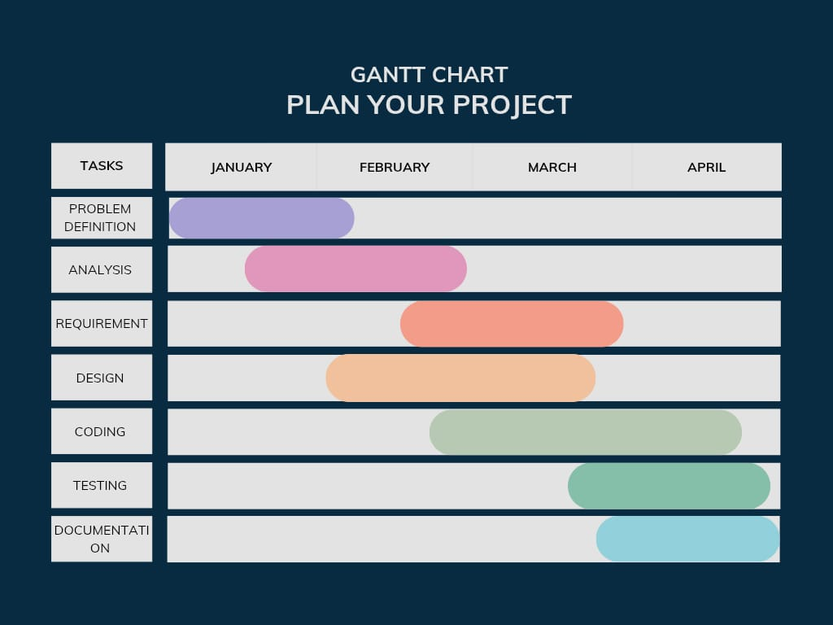

Chapter no.6
SOURCE CODE

    - SOURCE CODE

from dotenv import load_dotenv
load_dotenv() # load environment variables

import streamlit as st
import os
import google.generativeai as genai
from supabase import create_client, Client
from datetime import datetime

# Configure Gemini
genai.configure(api_key=os.getenv("GOOGLE_API_KEY"))
model = genai.GenerativeModel("gemini-2.0-flash")
chat = model.start_chat(history=[])

# Configure Supabase
supabase_url = os.getenv("SUPABASE_URL")
supabase_key = os.getenv("SUPABASE_KEY")
bucket_name = os.getenv("SUPABASE_BUCKET")
supabase: Client = create_client(supabase_url, supabase_key)

def get_gemini_response(question):
response = chat.send_message(question, stream=True)
return response

def save_chat_to_supabase(history):
content = "\n".join([f"{role}: {text}" for role, text in history])
filename = f"chat_{datetime.now().strftime('%Y%m%d_%H%M%S')}.txt"
with open(filename, "w") as f:
f.write(content)

with open(filename, "rb") as f:

supabase.storage.from_(bucket_name).upload(filename, f)

os.remove(filename) # clean up local file

# Streamlit app
st.set_page_config(page_title="Q&A Demo")
st.header("WALL-E")

if 'chat_history' not in st.session_state:
st.session_state['chat_history'] = []

input = st.text_input("Input: ", key="input")
submit = st.button("Ask the question")

if submit and input:
response = get_gemini_response(input)
st.session_state['chat_history'].append(("You", input))
st.subheader("The Response is")
full_response = ""
for chunk in response:
st.write(chunk.text)
full_response += chunk.text
st.session_state['chat_history'].append(("Bot", full_response))

# Save chat to Supabase
save_chat_to_supabase(st.session_state['chat_history'])

st.subheader("The Chat History is")
for role, text in st.session_state['chat_history']:
st.write(f"{role}

Chapter no. 7
RESULT

RESULT

Output :

      - IMPLEMENTATION

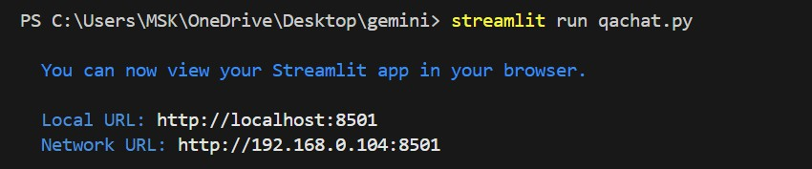

      - RESPONSE

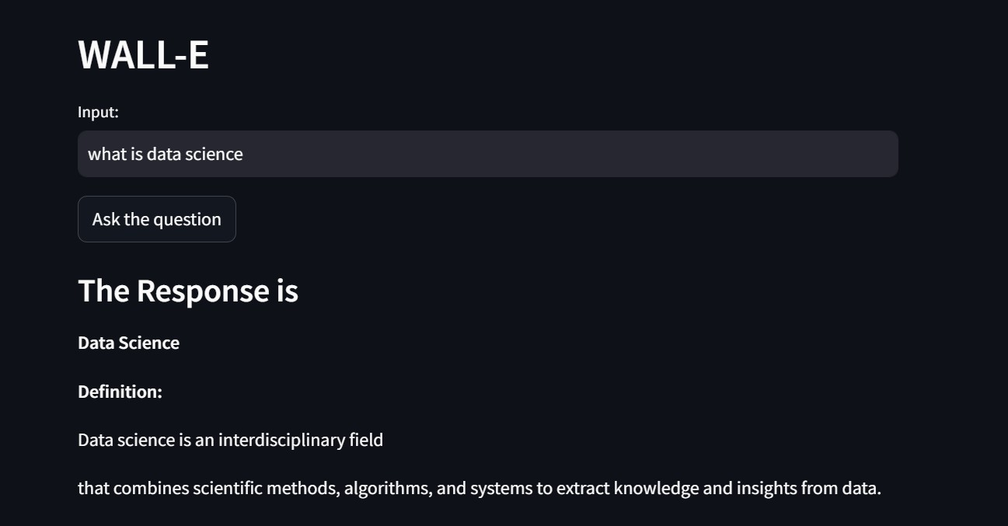

      - CHAT HISTORY

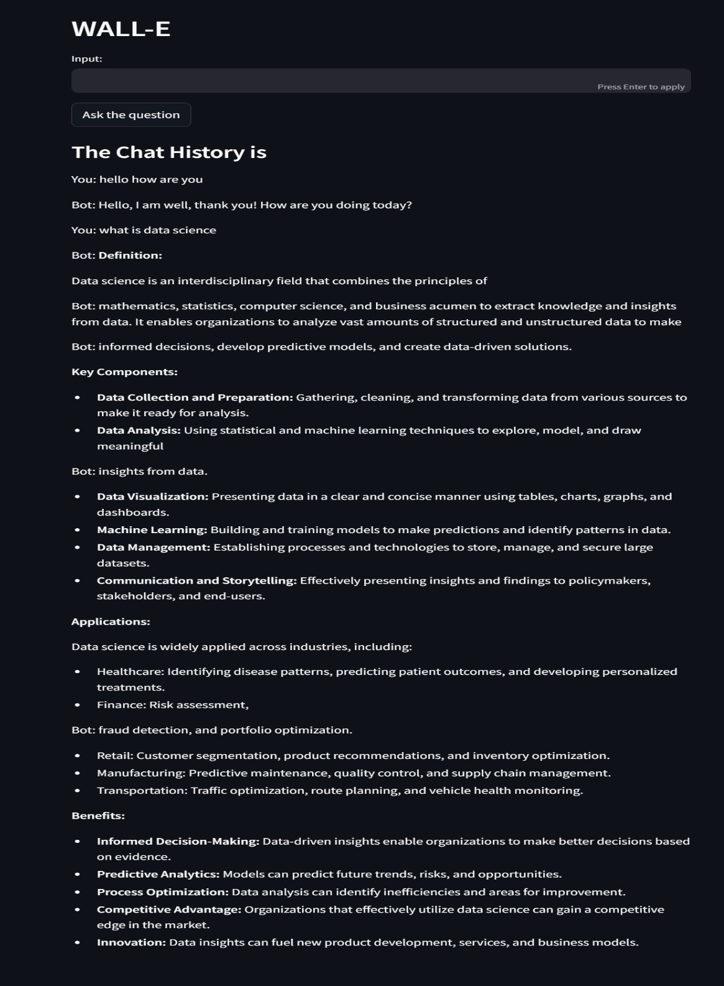

CLOUD STORAGE

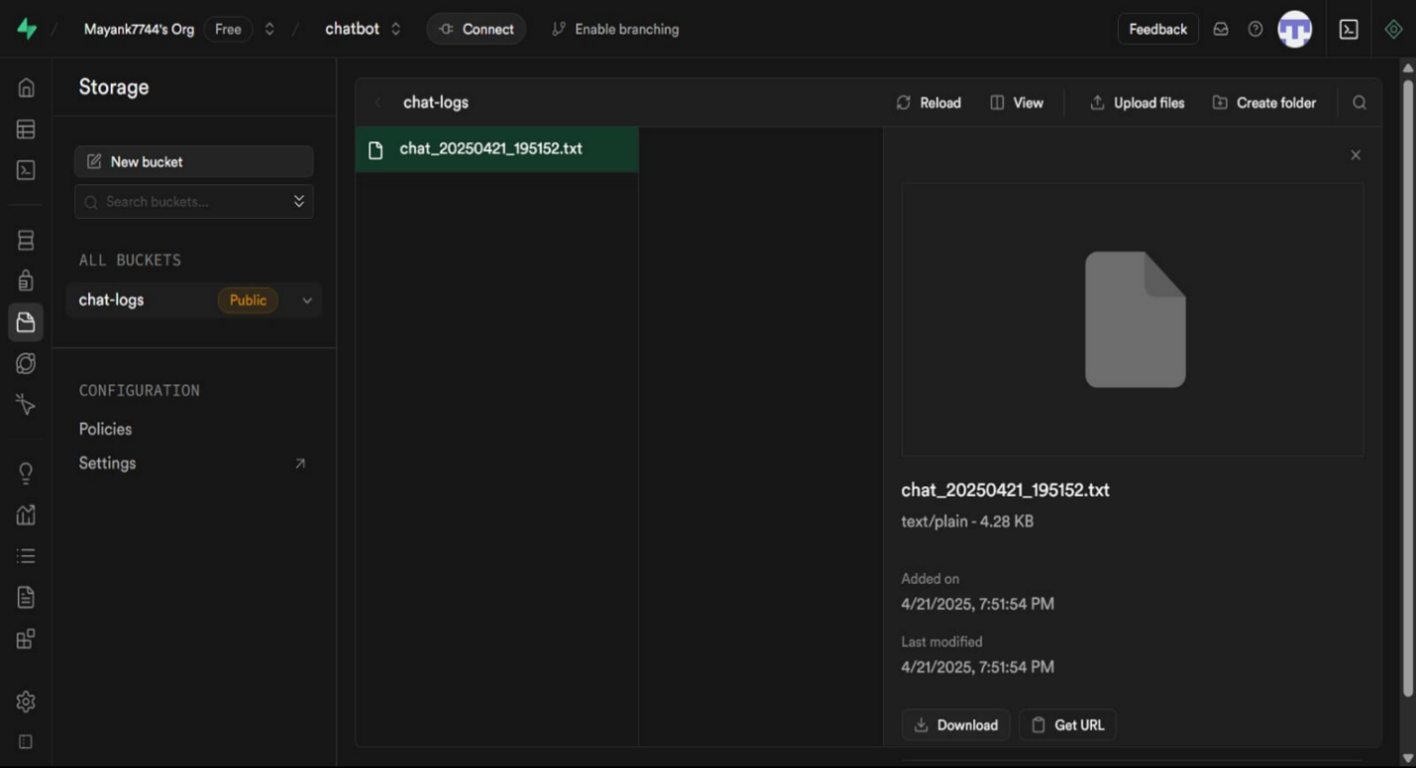

Conclusion

The development of an AI chatbot integrated with Supabase cloud storage presents an effective solution for creating intelligent, scalable, and interactive systems. By combining natural language processing with real-time data handling and secure cloud-based backend services, the chatbot enhances user experience, simplifies backend management, and supports personalization. This project demonstrates the potential of leveraging modern cloud platforms like Supabase to build efficient and future-ready AI applications.

REFERENCE

        - Grandviewresearch. “Chatbot Market Growth & Trends”. 2022[cited 2022 14 June]; Available from: https://www.grandviewresearch.com/press-release/global-chatbot- market.
        - Dale, R., The return of the chatbots. Natural Language Engineering, 2016. 22(5): p. 811-817..
        - McTear, M.F. The rise of the conversational interface: “A new kid on the block? in International workshop on future and emerging trends in language technology. 2016”. Springer.
        - Følstad, A. and P.B. Brandtzæg, “Chatbots and the new world of HCI”. interactions, 2017. 24(4): p. 38-42.
        - Radziwill, N.M. and M.C. Benton, “Evaluating quality of chatbots and intelligent conversational agent”,. arXiv preprint arXiv:1704.04579, 2017.
        - ​Gkinko, L. and A. Elbanna, Hope,” tolerance and empathy: employees' emotions when using an AI enabled chatbot in a digitalised workplace”. Information Technology & People, 2022: p. 30.
        - Gkinko, L.E., Amany, Chatbots at Work: A Taxonomy of the Use of Chatbots in the workplace, in Responsible AI and Analytics for an Ethical and Inclusive Digitized Society. 20th IFIP WG 6.11 Conference on e-Business, e-Services and e- Society, I3E 2021, , A.G. D. Dennehy, N. Pouloudi, Y. K. Dwivedi, I. Pappas, & M. Mäntymäki (Eds.), Editor. 2021: Galway, Ireland, September 1 3, 2021.

